**Assignment 2: Data Analytics with Tableau**

* **Name: K AISHA RUQSHAN**

**• Roll Number: 22BFA32045**

**• Course: Data Analytics with Tableau**

**• Assignment: Assignment 2**

**Title:**

*Supermarket Sales Data Visualization and Analysis*

**Introduction:**

This assignment focuses on analyzing supermarket sales data collected from three branches over a period of three months. Using Tableau, various visualizations were created to understand sales trends, customer distribution, and product performance. The insights from this analysis can help the supermarket improve decision-making,marketing strategies, and customer experience.

**Visualizations:**

1. **Donut Chart - Payment Distribution**

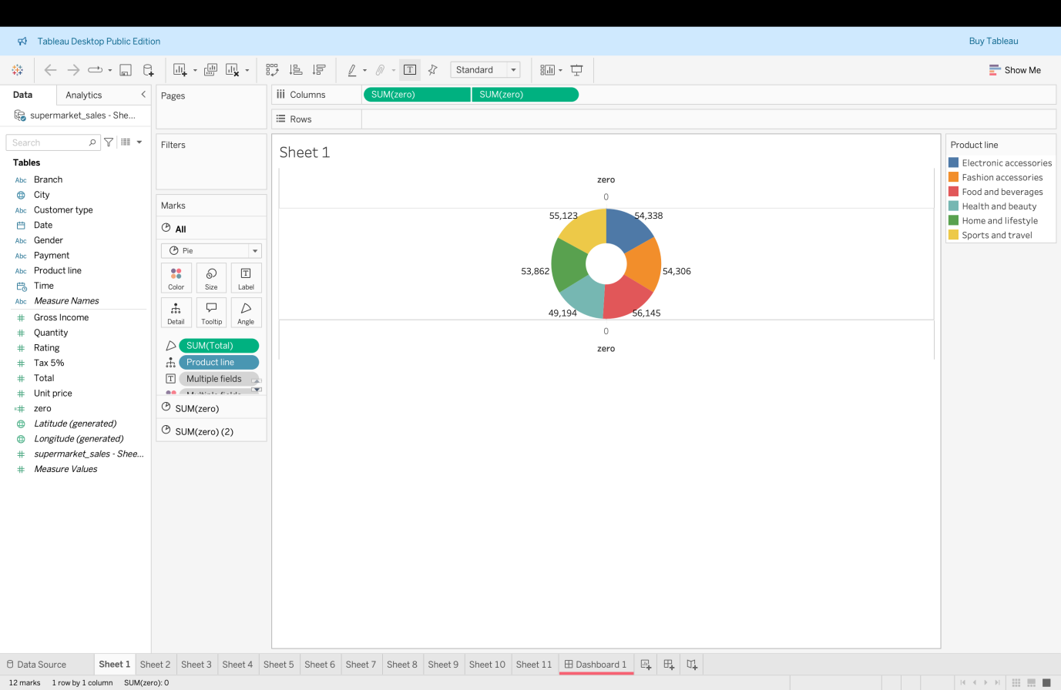

1. **Area Chart - Sales Over Time:**

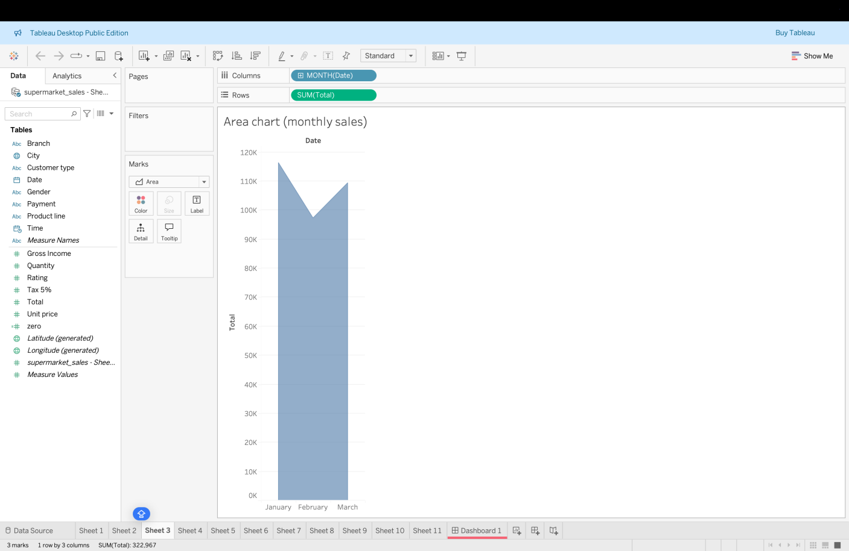

The area chart displays how total sales have changed over time. It helps to track sales performance across different days or months.

1. **Text Table - Sales by Product Line:**

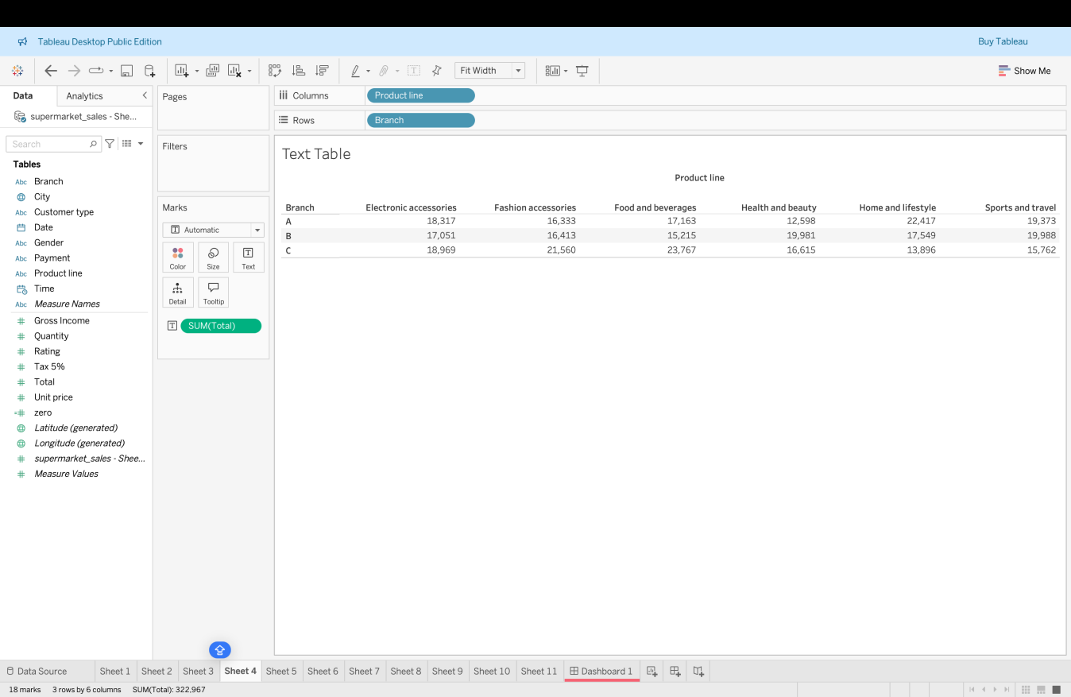

The text table shows the total sales for each product line. It provides exact numerical sales values, which helps in comparing the performance of different product categories.

1. **Highlighted Table - Sales Comparison by City and Product Line:**

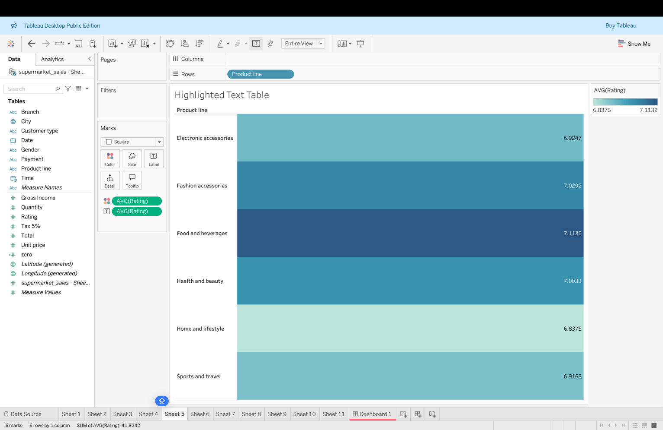

**The highlighted table visually compares sales across cities and product lines. The color highlights make it easy to see which products sold best in each city.**

1. **Word Cloud - Product Line Frequency:**

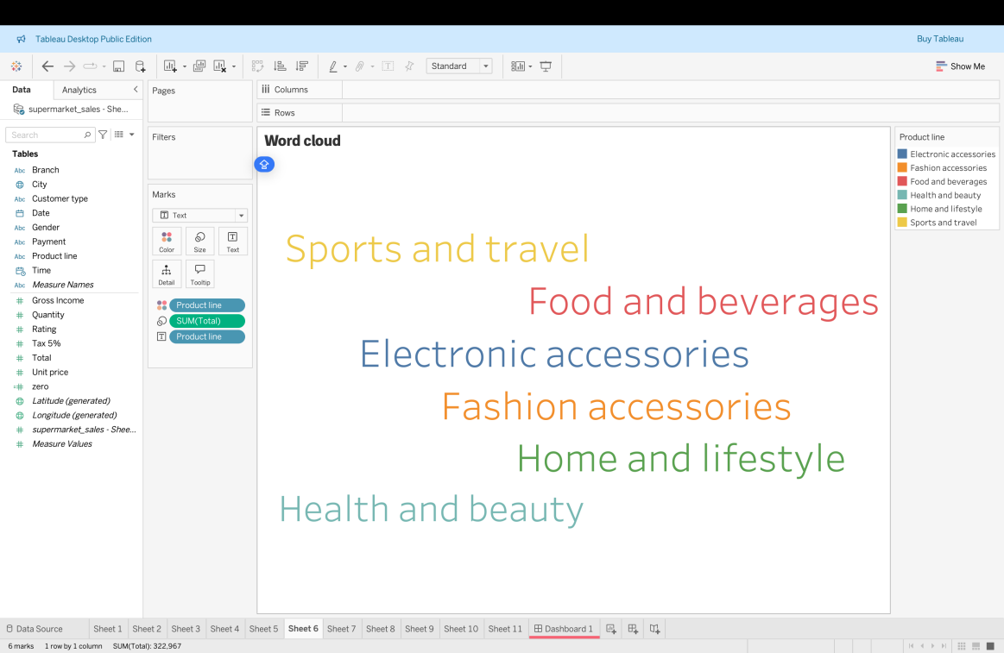

**The word cloud represents the most frequent product lines purchased by customers. Larger words indicate more sales or higher frequency.**

1. **Funnel Chart - Sales by Product Line:**

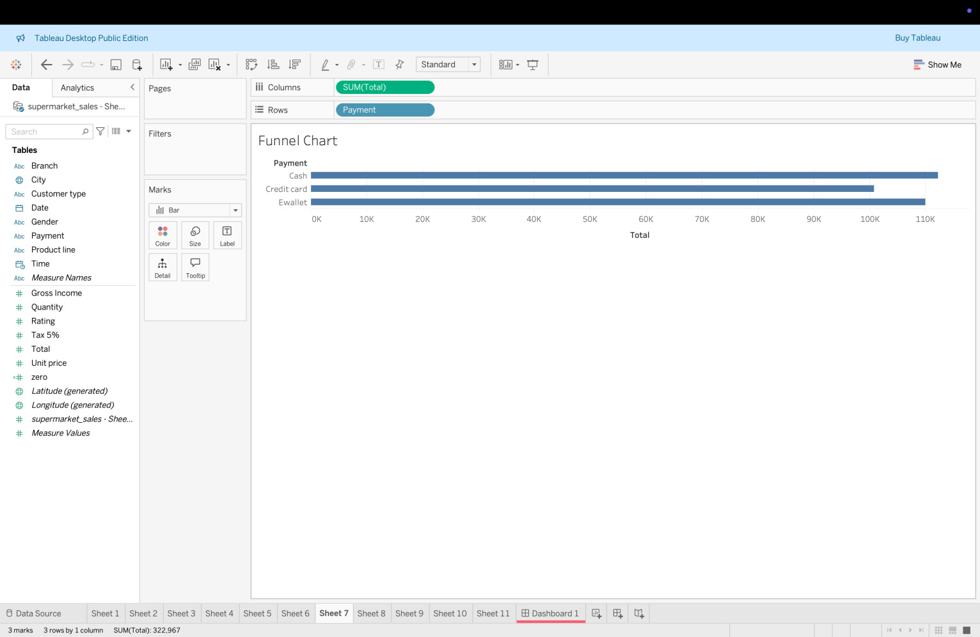

The funnel chart shows the step-by-step reduction in sales across different product lines. It helps to visualize which product categories have the highest or lowest sales.

**7. Waterfall Chart - Sales Flow using Total**

The waterfall chart displays how sales (Total) increase or decrease across different product lines. It helps to understand the flow and changes in sales step by step.

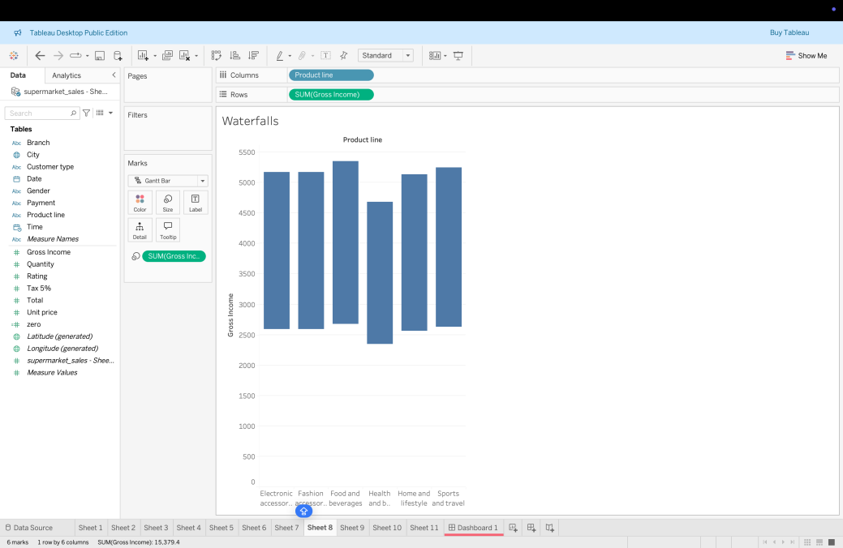

**CONCLUSION:**

Through this analysis, we observed key patterns in customer preferences, product performance, and payment methods. These visualizations provide valuable insights that can support business growth and enhance customer satisfaction. Tableau's visual tools made it easy to identify trends and compare different factors

effectively.